Crypto Optimal Analysis for LONGS Based on Trendline Slope
Current time 2021-06-01 15:57:08.354240

Buy Signals for
BUY Signals (in order) for
4 ETCUSDT
10 XMRUSDT
11 LTCUSDT
17 BNBUSDT
18 BCHUSDT
21 ETHUSDT
23 BTCUSDT
28 EOSUSDT
30 WAVESUSDT
31 DASHUSDT
35 RLCUSDT
Name: Pair, dtype: object

Pair Selection Based on Trendline Slope
Standard Deviation 0.04246072071066052
Volume 73,137.822909
Fibonacci (Price <= Golden Range) True
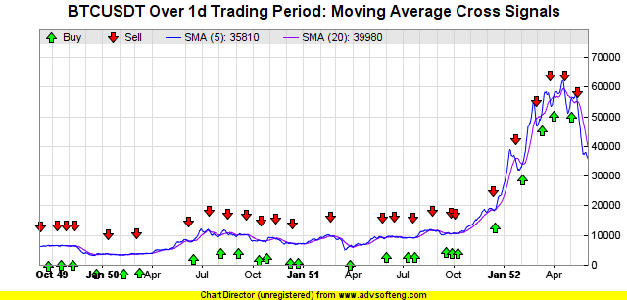
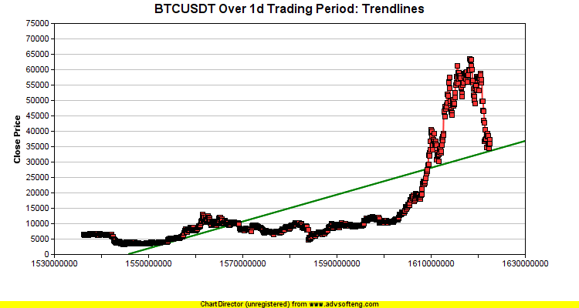
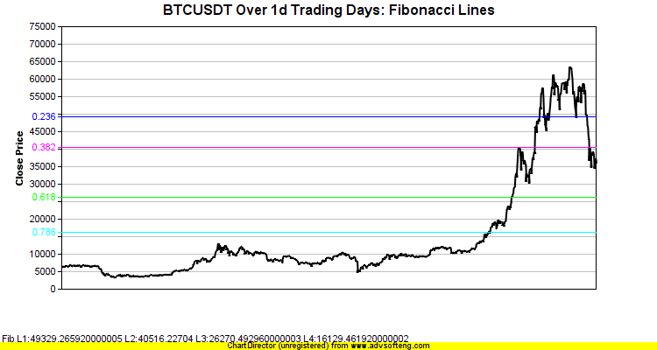

Pair Selection Based on Trendline Slope
Standard Deviation 0.05953673848849995
Volume 123,680.53603
Fibonacci (Price <= Golden Range) True
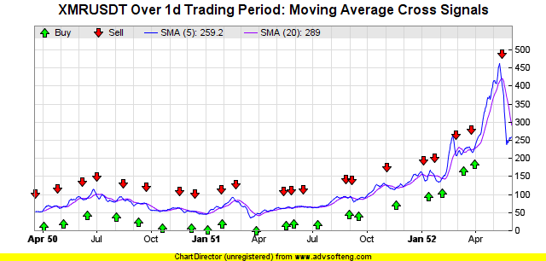
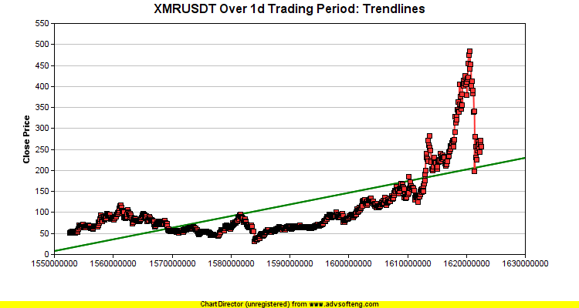
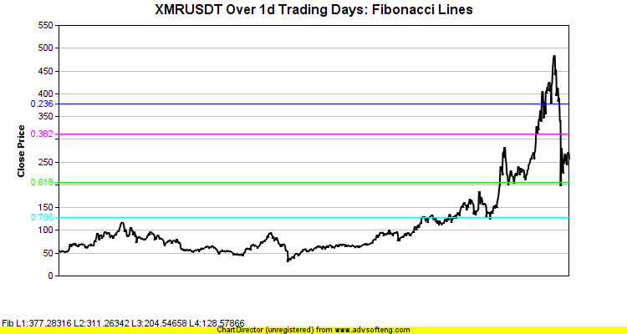

Pair Selection Based on Trendline Slope
Standard Deviation 0.0660024649466077
Volume 141,738.10081
Fibonacci (Price <= Golden Range) True
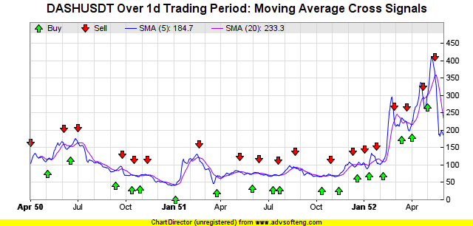
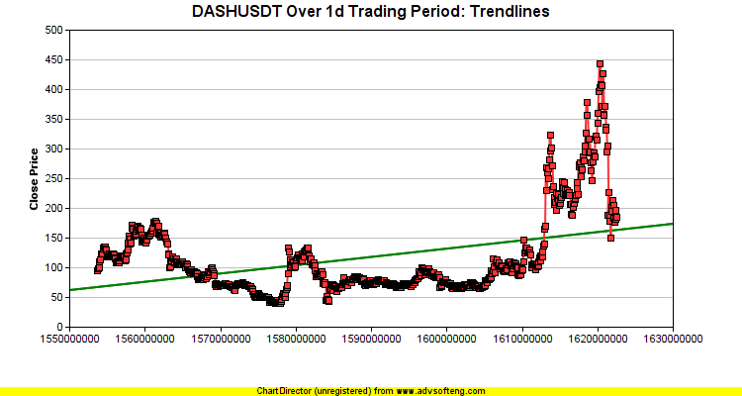
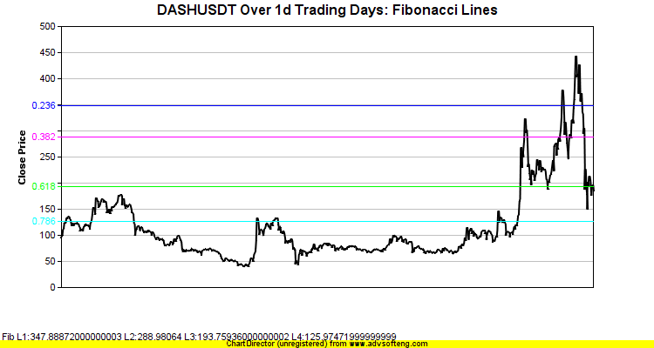

Pair Selection Based on Trendline Slope
Standard Deviation 0.0747170283972732
Volume 143,685.53706
Fibonacci (Price <= Golden Range) True
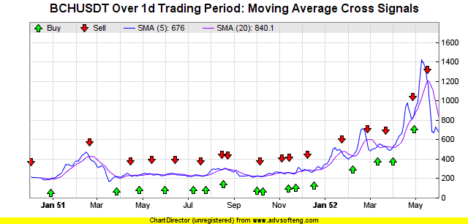
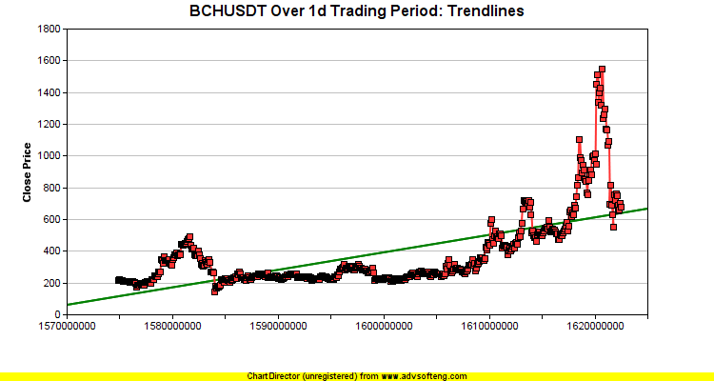
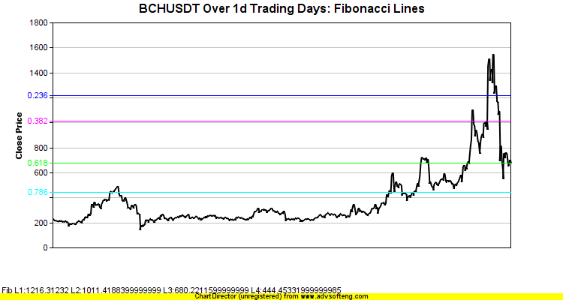

Pair Selection Based on Trendline Slope
Standard Deviation 0.05885803029564709
Volume 976,125.88514
Fibonacci (Price <= Golden Range) True
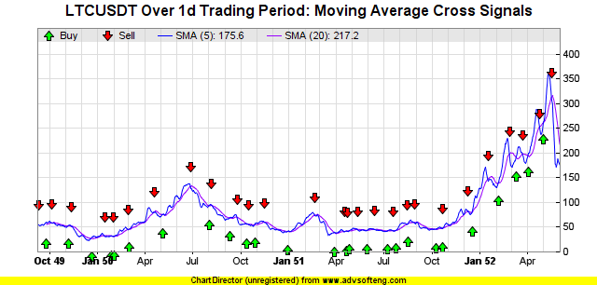
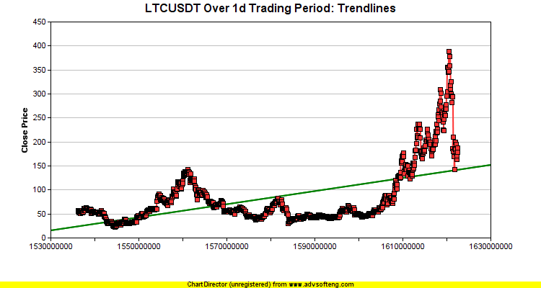
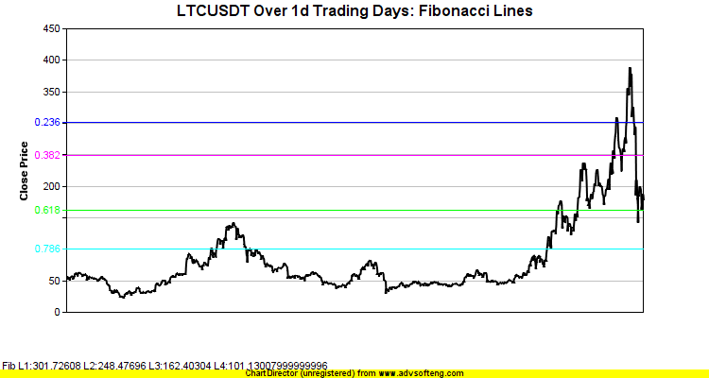

Pair Selection Based on Trendline Slope
Standard Deviation 0.057052772034019185
Volume 1,051,283.99484
Fibonacci (Price <= Golden Range) True
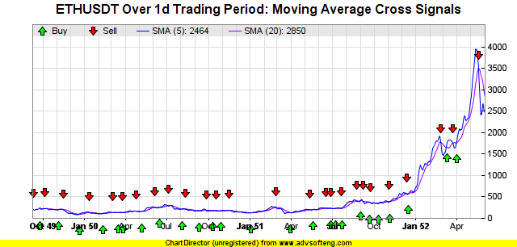
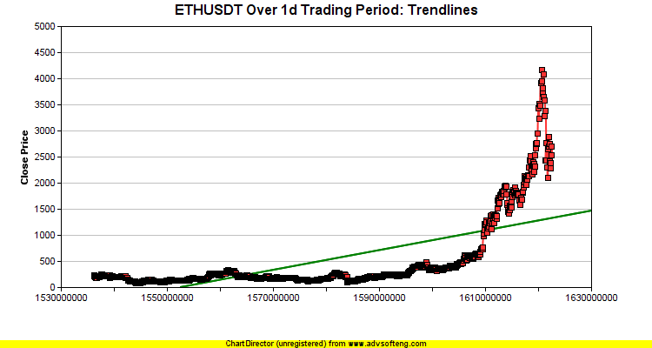
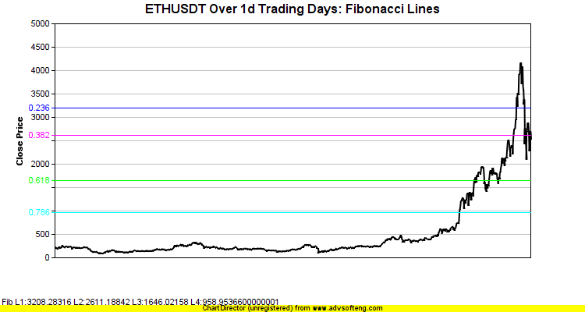

Pair Selection Based on Trendline Slope
Standard Deviation 0.06741218100995677
Volume 1,651,360.966
Fibonacci (Price <= Golden Range) True
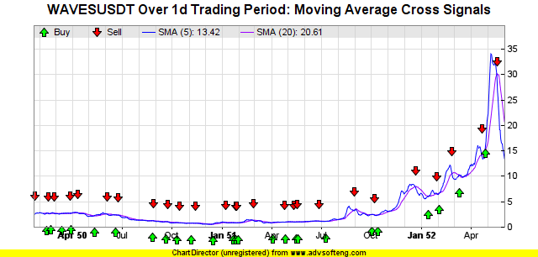
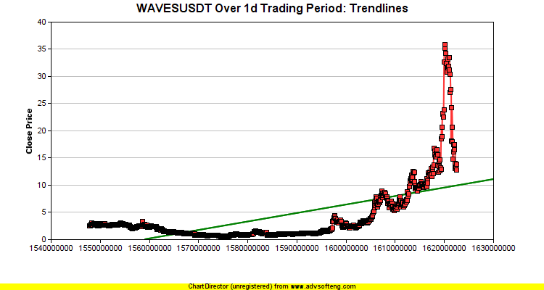
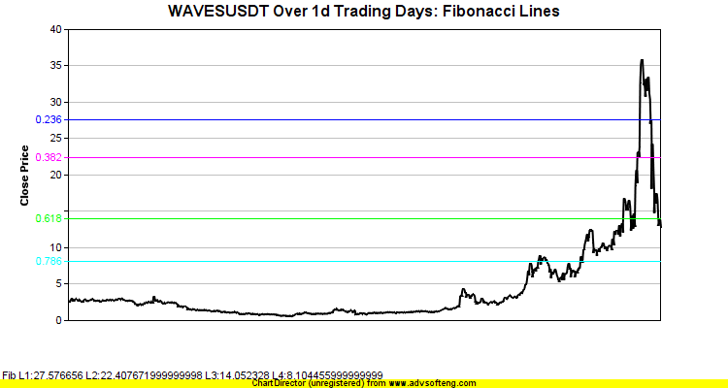

Pair Selection Based on Trendline Slope
Standard Deviation 0.0641708078486358
Volume 2,435,799.803
Fibonacci (Price <= Golden Range) True
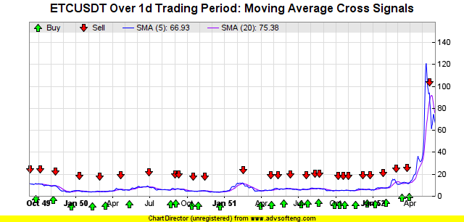
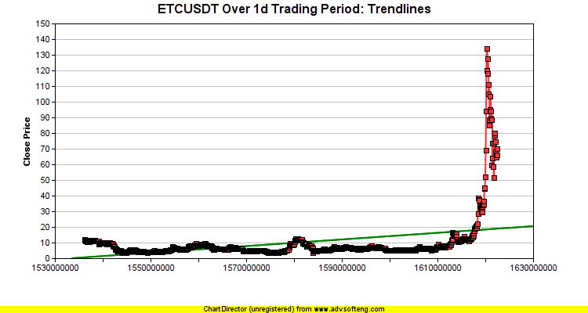
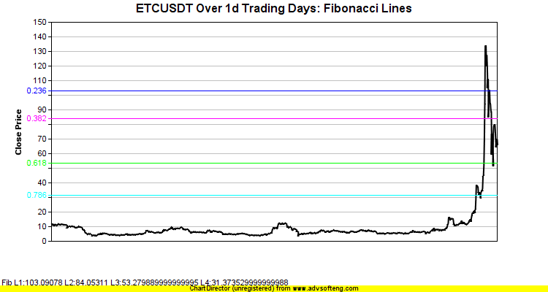

Pair Selection Based on Trendline Slope
Standard Deviation 0.061862223224693695
Volume 3,198,743.7768
Fibonacci (Price <= Golden Range) True
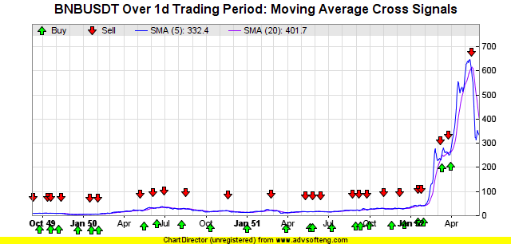
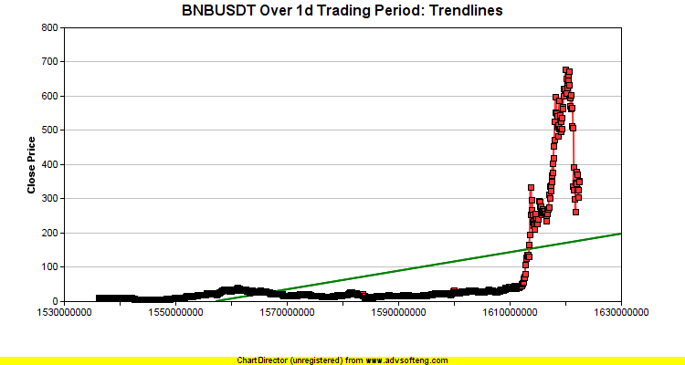
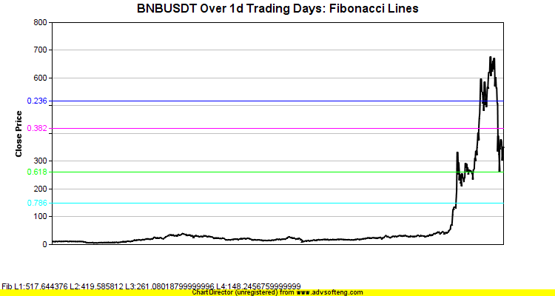

Pair Selection Based on Trendline Slope
Standard Deviation 0.10231080535499137
Volume 8,550,461.14
Fibonacci (Price <= Golden Range) True
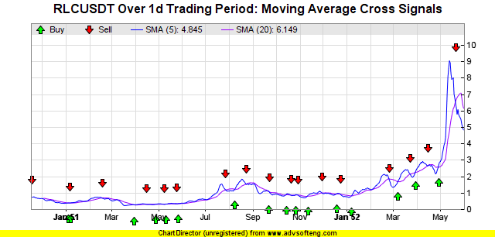
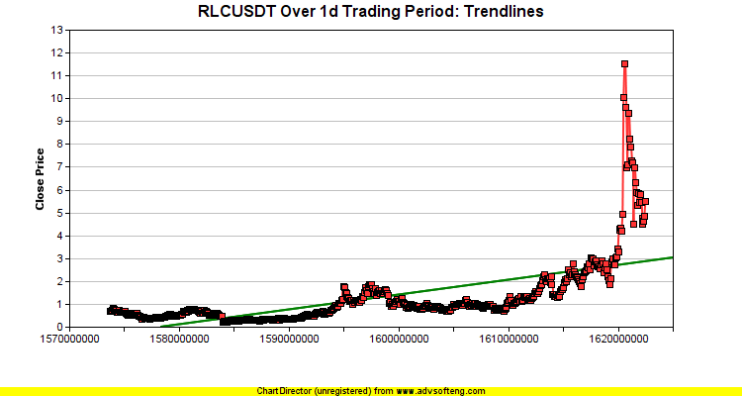
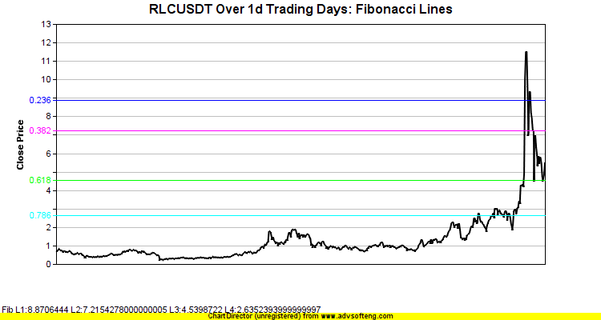

Pair Selection Based on Trendline Slope
Standard Deviation 0.0668596020864247
Volume 36,741,450.33
Fibonacci (Price <= Golden Range) True
