Crypto Optimal Analysis for LONGS
Current time 2021-06-01 15:56:18.592029

Buy Signals for
Crypto Pairs >- 40M
0 DOGEUSDT
1 USDCUSDT
2 BUSDUSDT
6 TRXUSDT
9 SHIBUSDT
12 XLMUSDT
19 BTTUSDT
24 CHZUSDT
25 TFUELUSDT
Name: Pair, dtype: object
Group Volume Mean 2,135,416,993,499.0334
Group Volatility Mean 0.07613593188239903

TFUELUSDT
Standard Deviation 0.08825123146926599
Volume 88,490,965.5
Fibonacci (Price <= Golden Range) False
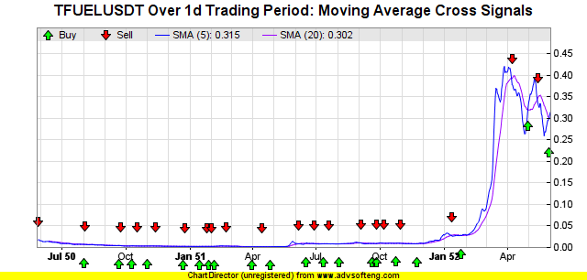
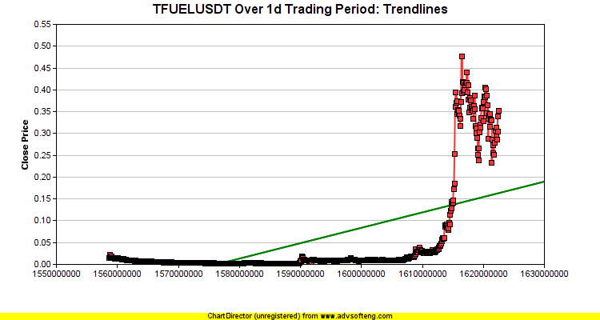
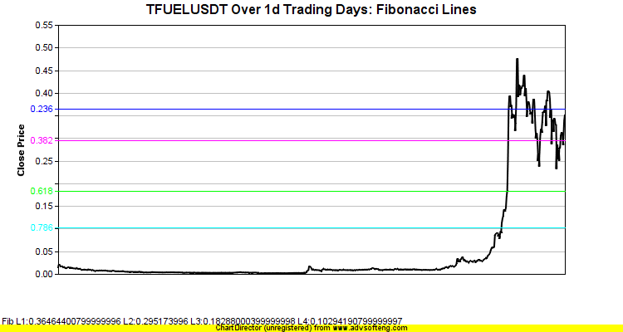
Detected Harmonic Pattern BullishButterflybinance-TFUELUSDT-1d.png
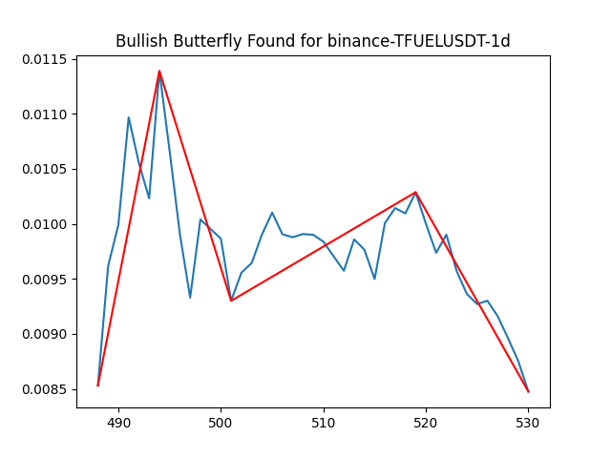
Detected Harmonic Pattern BearishButterflybinance-TFUELUSDT-1d.png
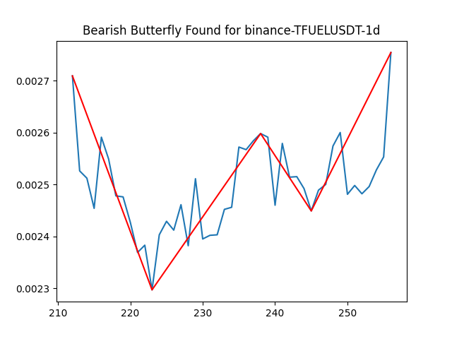
Head and Shoulder TFUELUSDT Lookback=1000(uses hourly data)
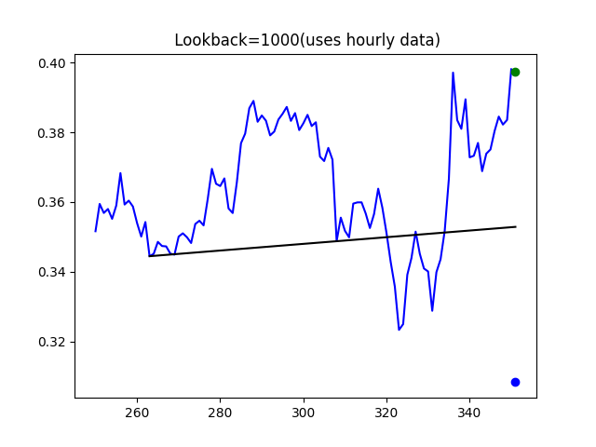
CANDLE PATTERN DETECTED for TFUELUSDT CDL3OUTSIDE with BEARISH signal at date time: 2021-05-28 20:00:00
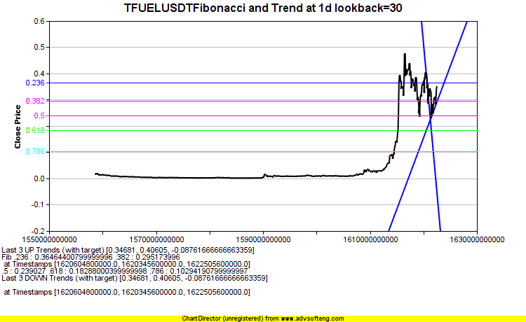
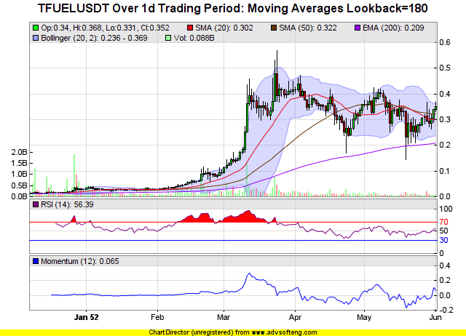
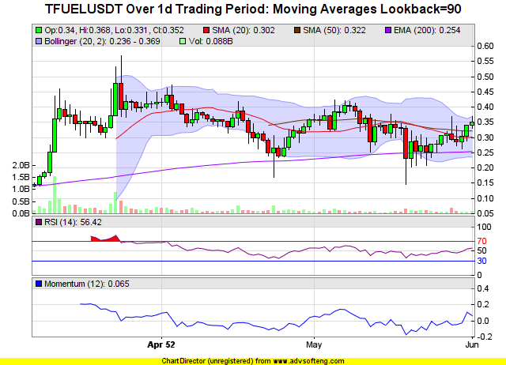
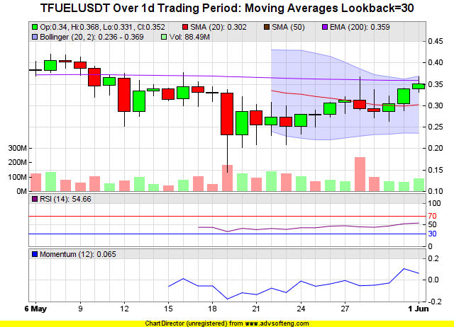

USDCUSDT
Standard Deviation 0.0021531228722642326
Volume 104,844,054.09
Fibonacci (Price <= Golden Range) True
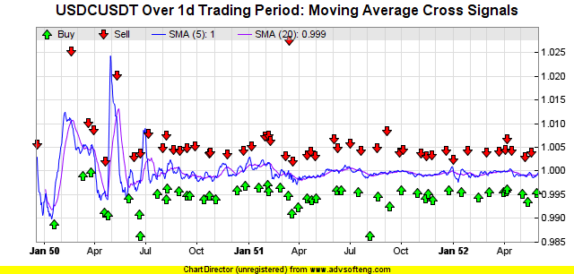
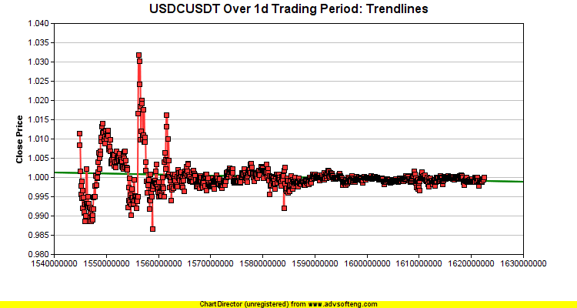
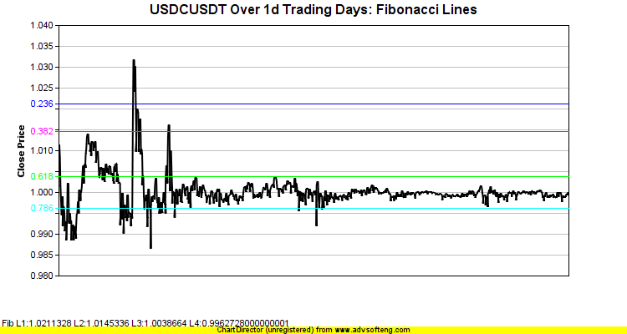
Detected Harmonic Pattern BullishButterflybinance-USDCUSDT-1d.png
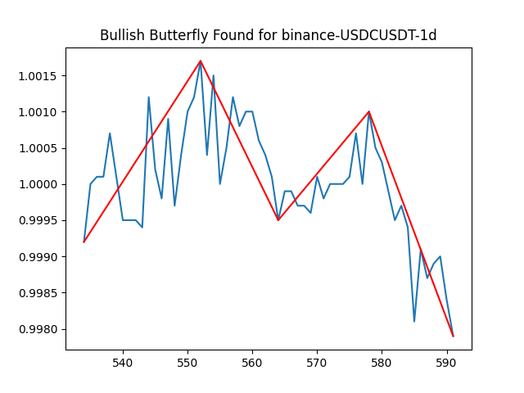
Detected Harmonic Pattern BearishBatbinance-USDCUSDT-1d.png
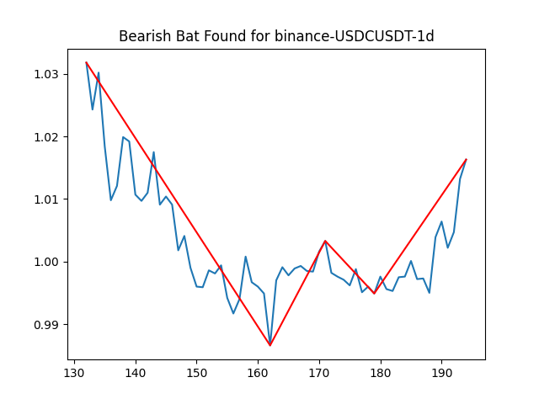
CANDLE PATTERN DETECTED for USDCUSDT CDLMARUBOZU with BULLISH signal at date time: 2021-05-30 20:00:00
CANDLE PATTERN DETECTED for USDCUSDT CDL3STARSINSOUTH with BULLISH signal at date time: 2021-05-28 20:00:00
CANDLE PATTERN DETECTED for USDCUSDT CDL3STARSINSOUTH with BULLISH signal at date time: 2021-05-29 20:00:00
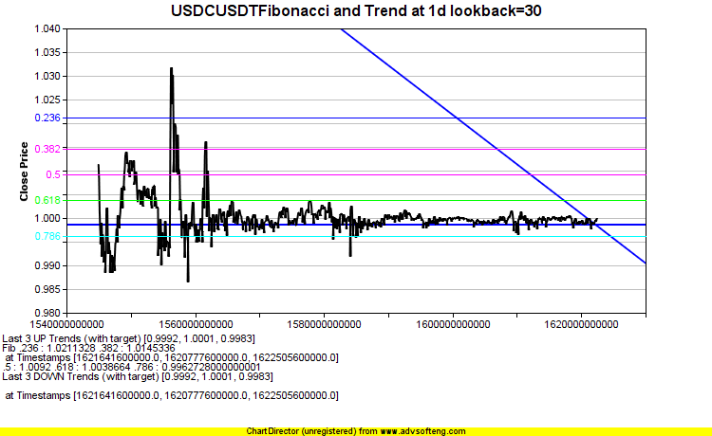
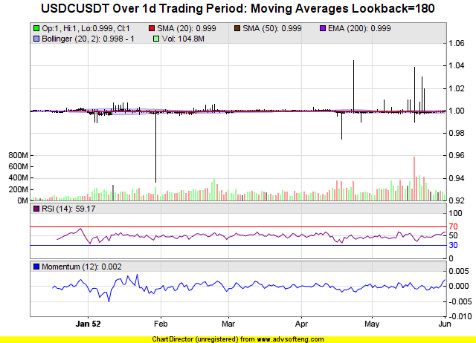
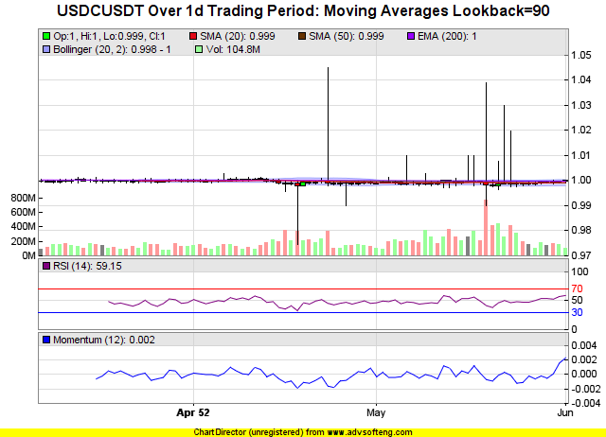
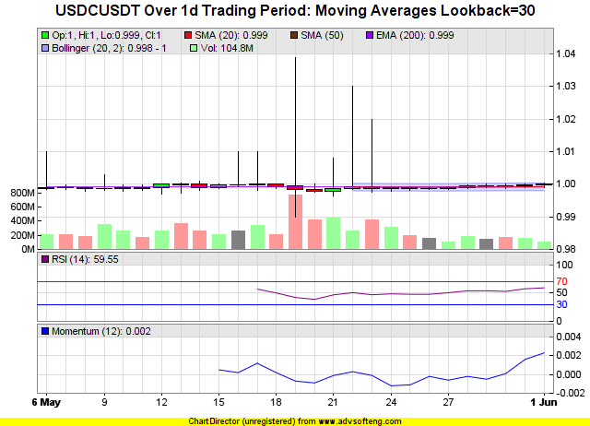

CHZUSDT
Standard Deviation 0.09154529210963279
Volume 181,104,520.3
Fibonacci (Price <= Golden Range) True
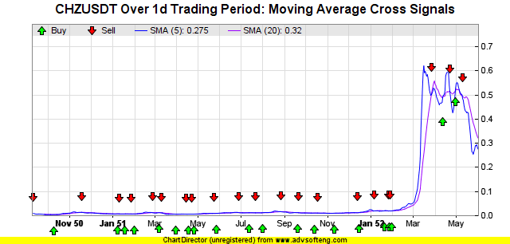
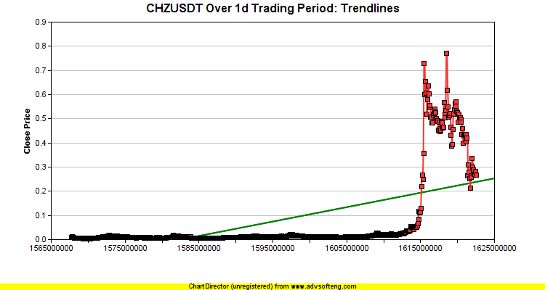
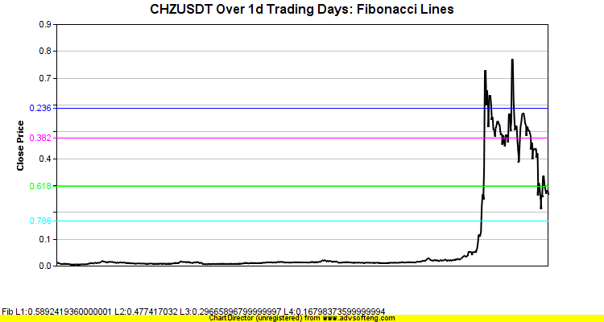
Detected Harmonic Pattern BearishBatbinance-CHZUSDT-1d.png
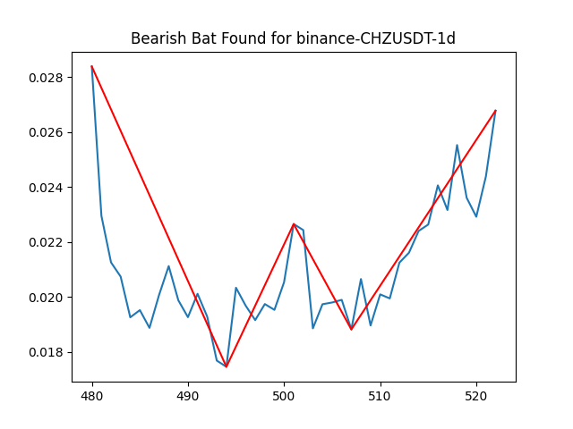
Head and Shoulder CHZUSDT Lookback=1000(uses hourly data)
CANDLE PATTERN DETECTED for CHZUSDT CDLMATCHINGLOW with BULLISH signal at date time: 2021-05-29 20:00:00
CANDLE PATTERN DETECTED for CHZUSDT CDL3STARSINSOUTH with BULLISH signal at date time: 2021-05-29 20:00:00
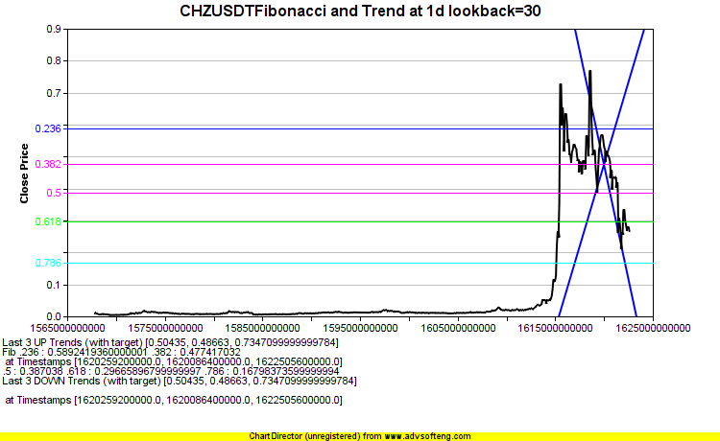
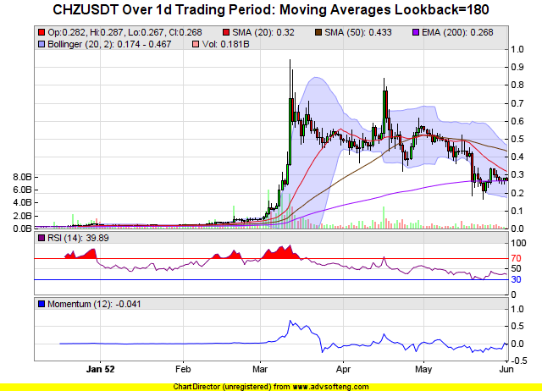
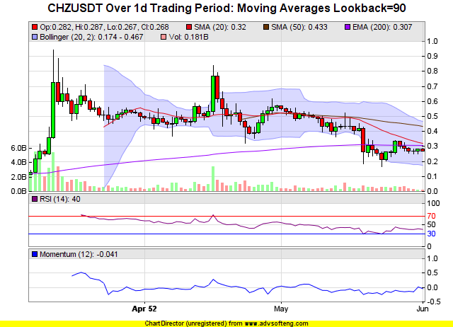
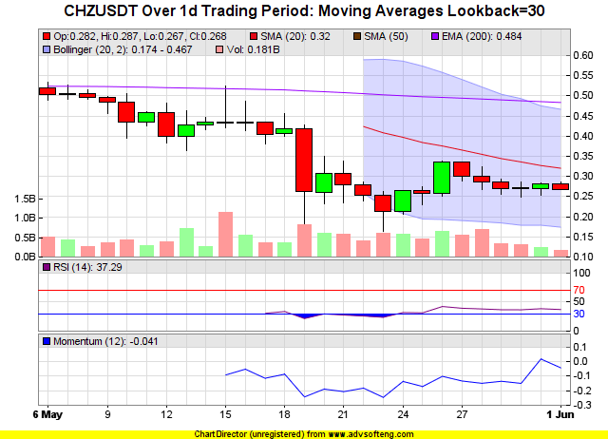

XLMUSDT
Standard Deviation 0.06149442191870893
Volume 379,112,794.1
Fibonacci (Price <= Golden Range) True
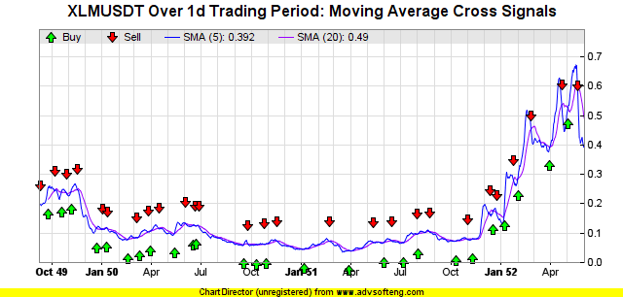
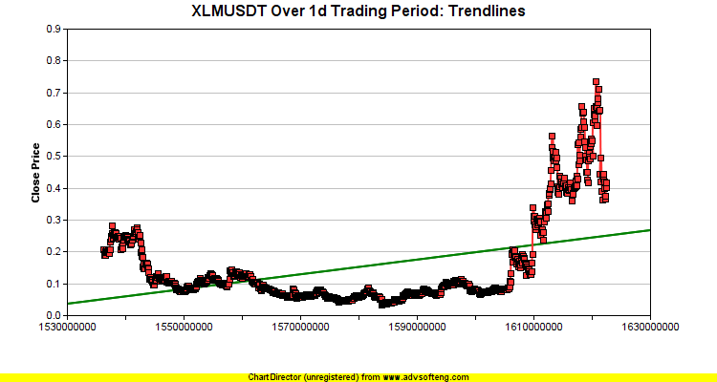
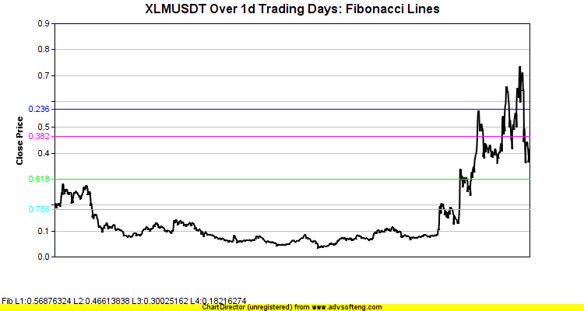
Detected Harmonic Pattern BullishCrabbinance-XLMUSDT-1d.png
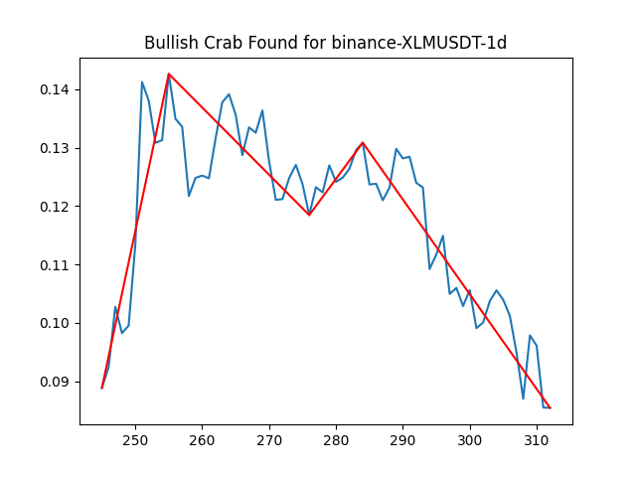
Detected Harmonic Pattern BearishButterflybinance-XLMUSDT-1d.png
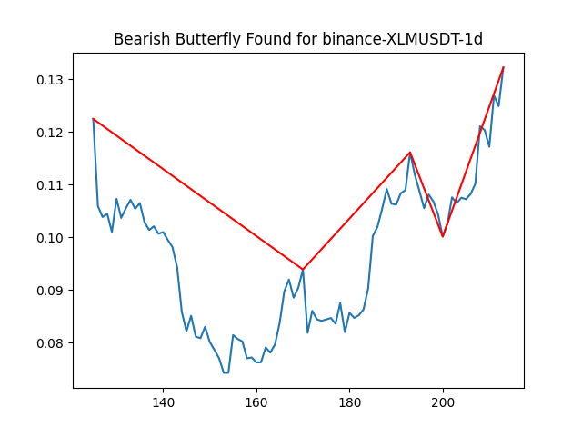
Head and Shoulder XLMUSDT Lookback=1000(uses hourly data)
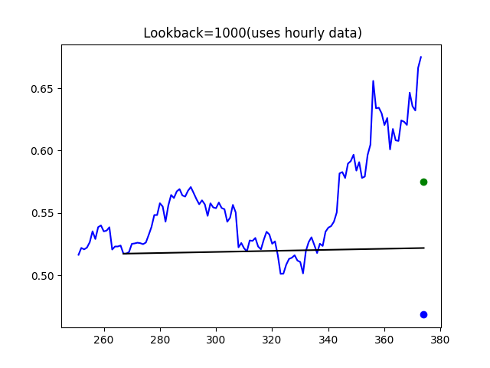
CANDLE PATTERN DETECTED for XLMUSDT CDL3OUTSIDE with BEARISH signal at date time: 2021-05-21 20:00:00
CANDLE PATTERN DETECTED for XLMUSDT CDL3STARSINSOUTH with BULLISH signal at date time: 2021-05-29 20:00:00
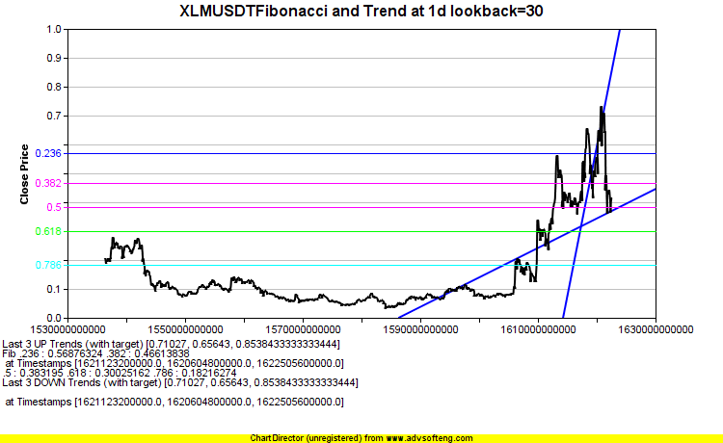
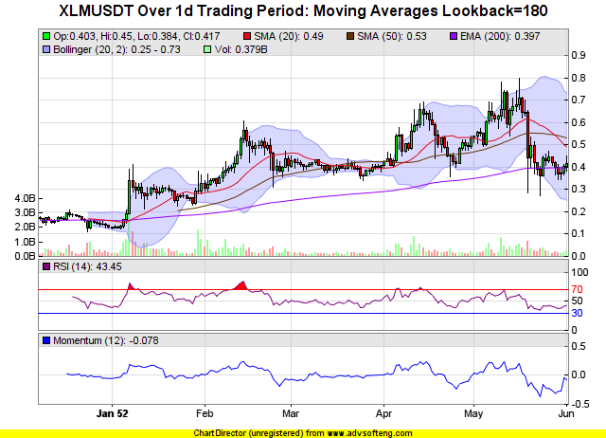
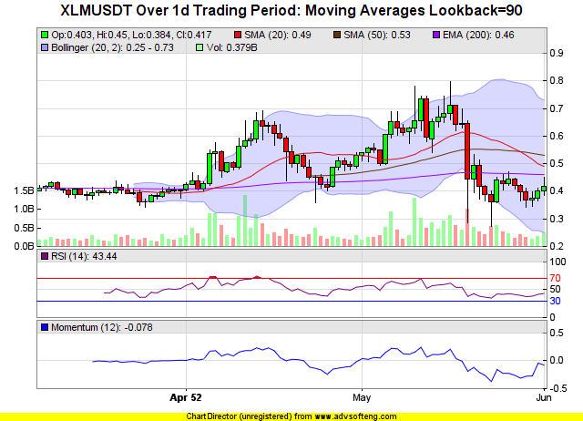
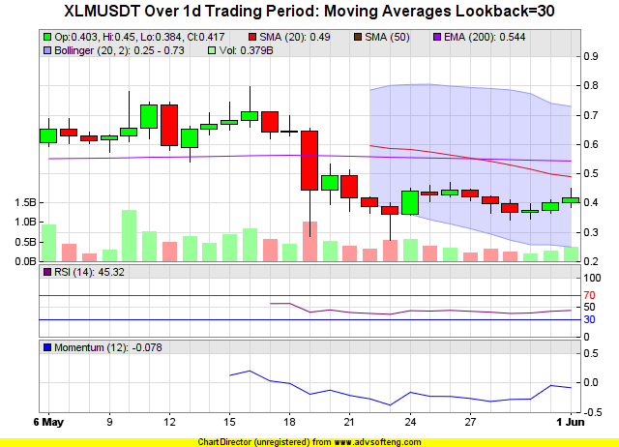

TRXUSDT
Standard Deviation 0.06233156795258093
Volume 1,127,036,309.9
Fibonacci (Price <= Golden Range) True
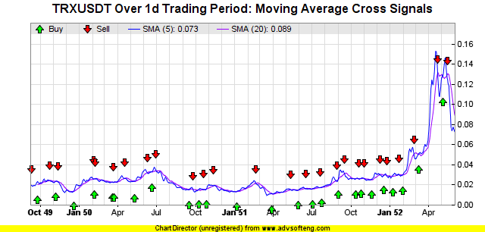
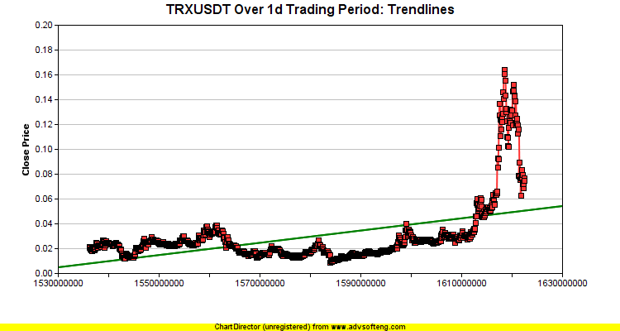
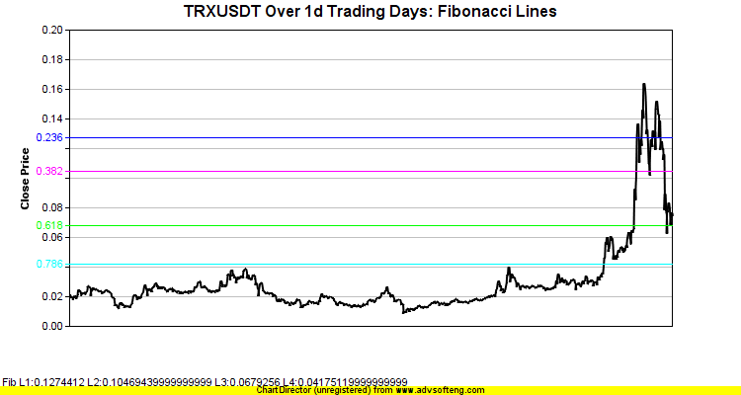
Detected Harmonic Pattern BullishGartleybinance-TRXUSDT-1d.png
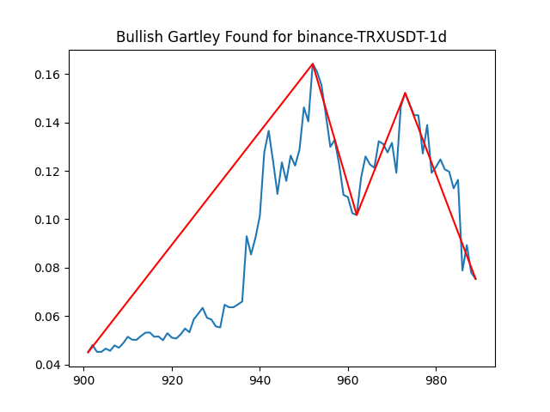
Detected Harmonic Pattern BearishButterflybinance-TRXUSDT-1d.png
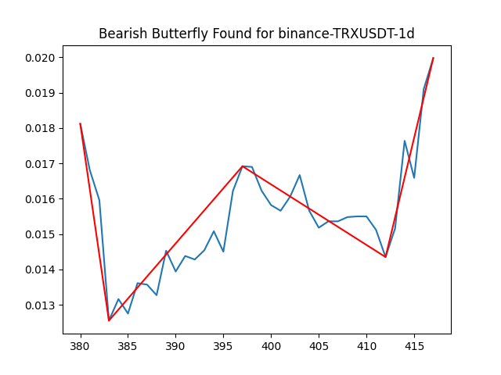
Head and Shoulder TRXUSDT Lookback=1000(uses hourly data)
CANDLE PATTERN DETECTED for TRXUSDT CDL3OUTSIDE with BULLISH signal at date time: 2021-05-24 20:00:00
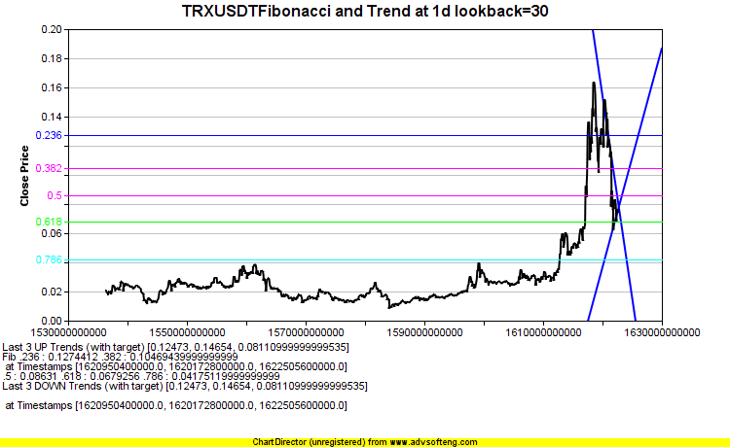
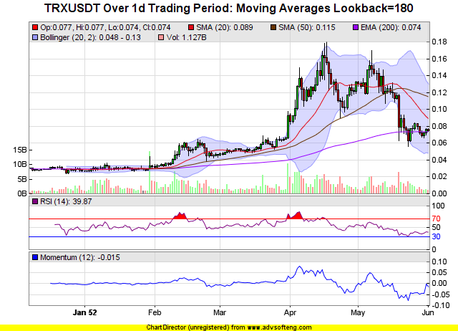
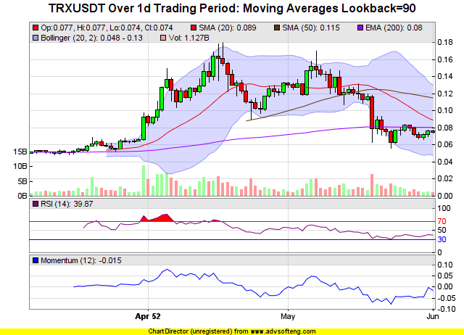
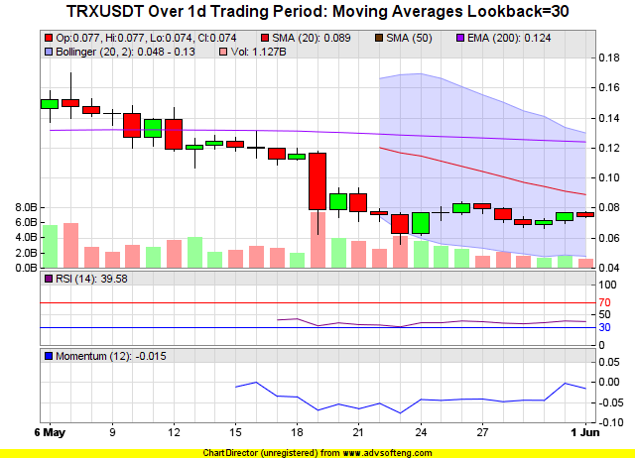

BUSDUSDT
Standard Deviation 0.0009550476091344944
Volume 1,295,434,727.31
Fibonacci (Price <= Golden Range) False
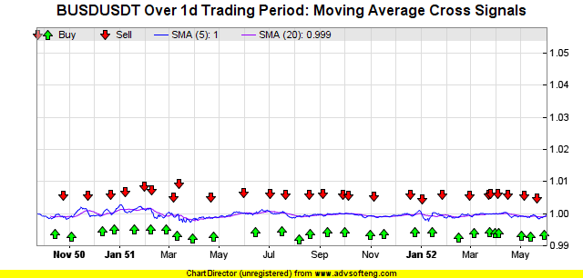
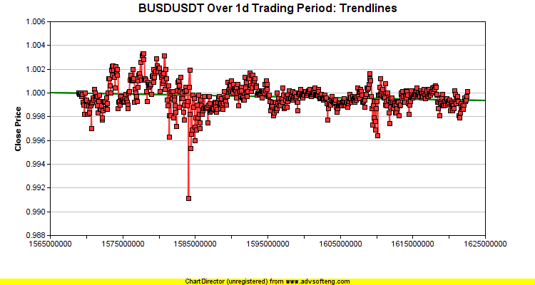
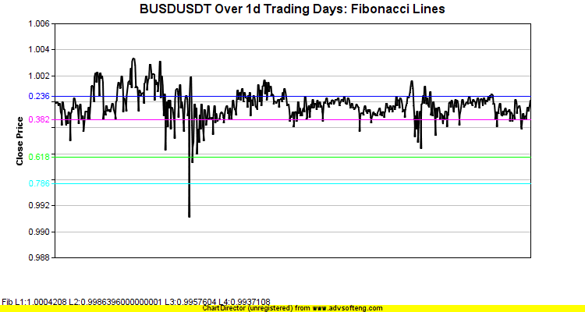
Detected Harmonic Pattern BullishButterflybinance-BUSDUSDT-1d.png
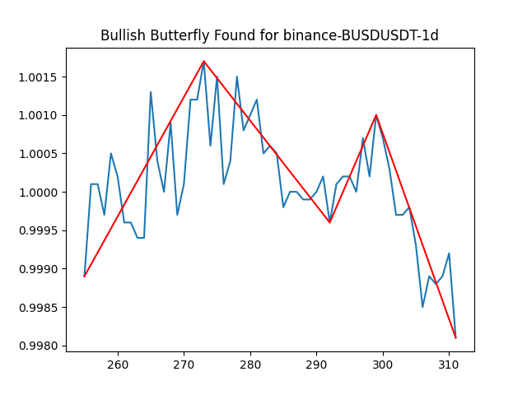
Head and Shoulder BUSDUSDT Lookback=1000(uses hourly data)
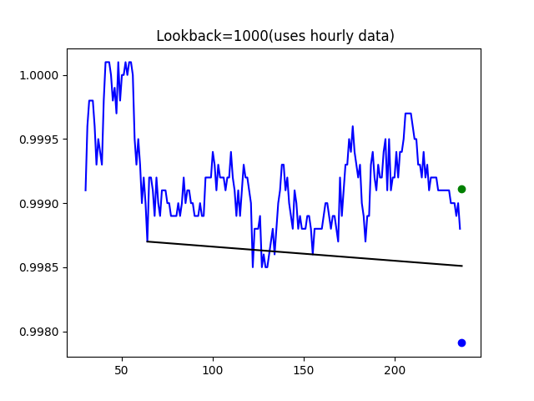
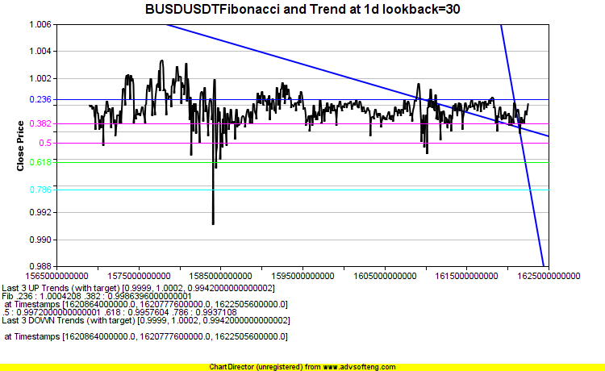
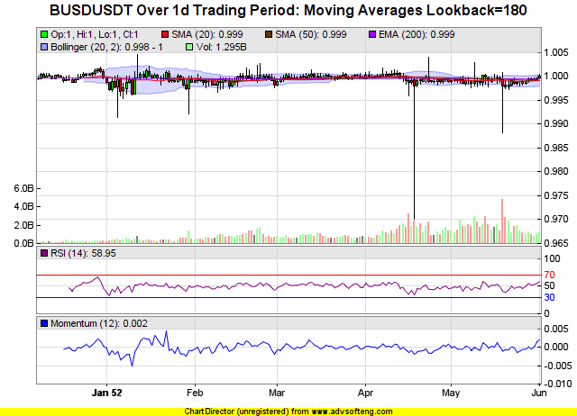
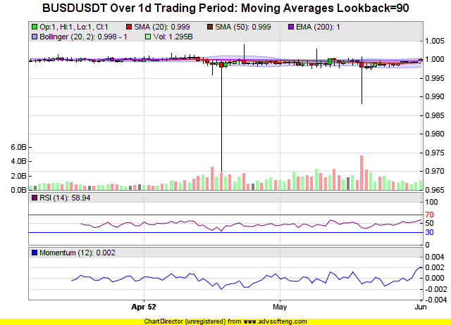
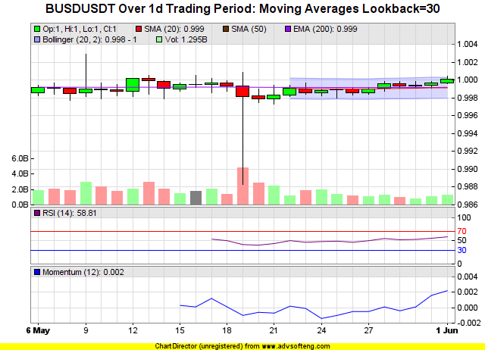

DOGEUSDT
Standard Deviation 0.08048162389459868
Volume 2,505,858,554.1
Fibonacci (Price <= Golden Range) True
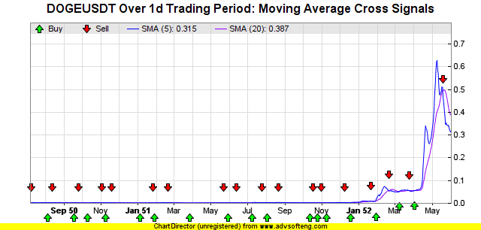
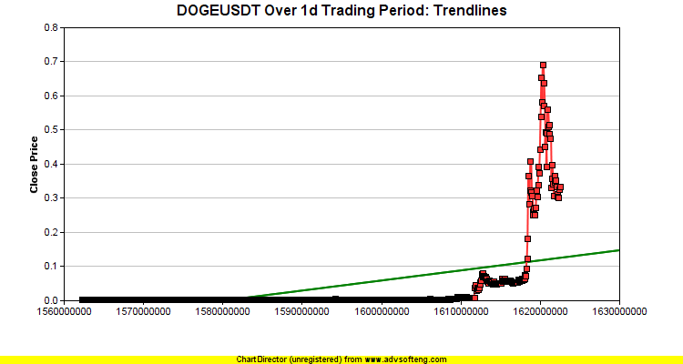
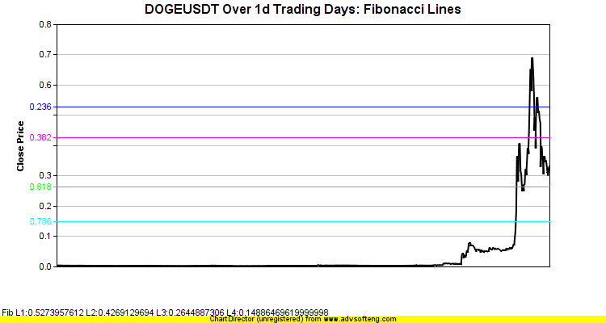
Detected Harmonic Pattern BearishBatbinance-DOGEUSDT-1d.png
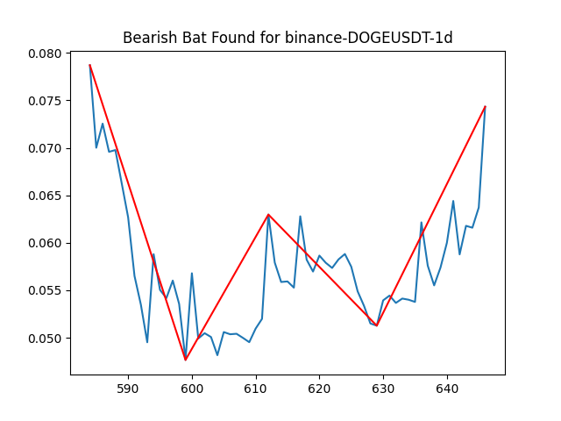
Head and Shoulder DOGEUSDT Lookback=1000(uses hourly data)
CANDLE PATTERN DETECTED for DOGEUSDT CDL3OUTSIDE with BEARISH signal at date time: 2021-05-27 20:00:00
CANDLE PATTERN DETECTED for DOGEUSDT CDLMATCHINGLOW with BULLISH signal at date time: 2021-05-29 20:00:00
CANDLE PATTERN DETECTED for DOGEUSDT CDL3STARSINSOUTH with BULLISH signal at date time: 2021-05-29 20:00:00
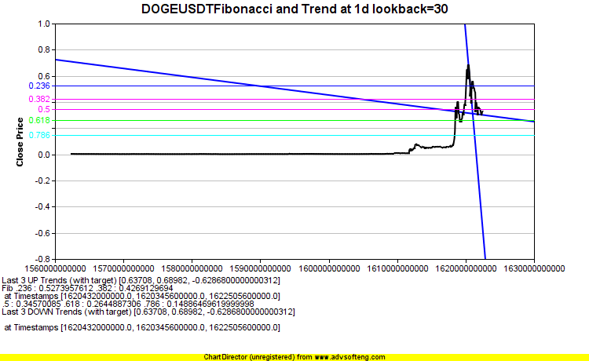
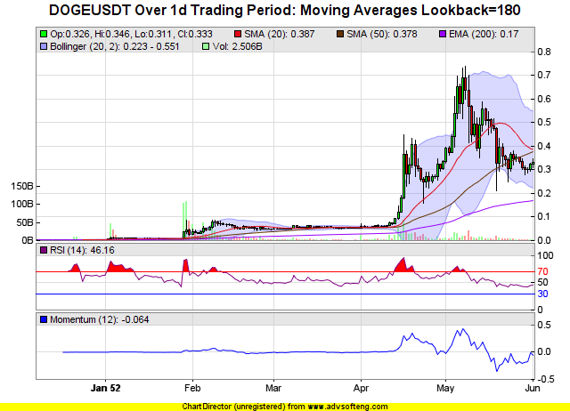
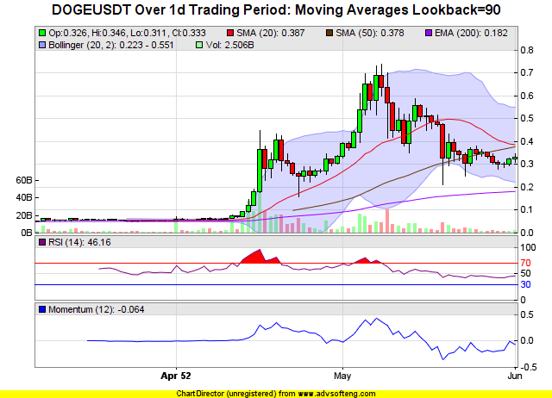
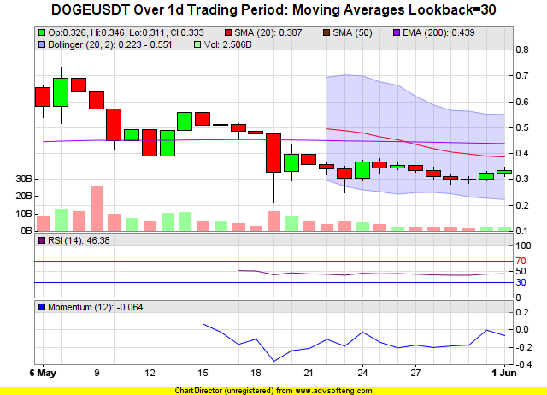

BTTUSDT
Standard Deviation 0.07031255521423509
Volume 8,404,957,910.0
Fibonacci (Price <= Golden Range) True
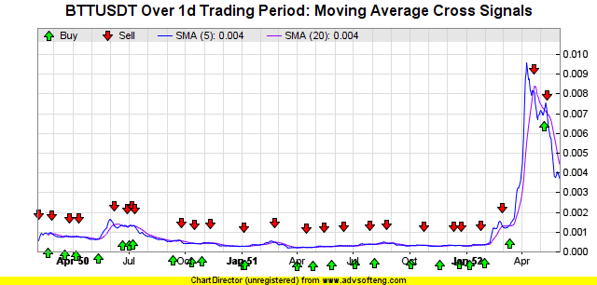
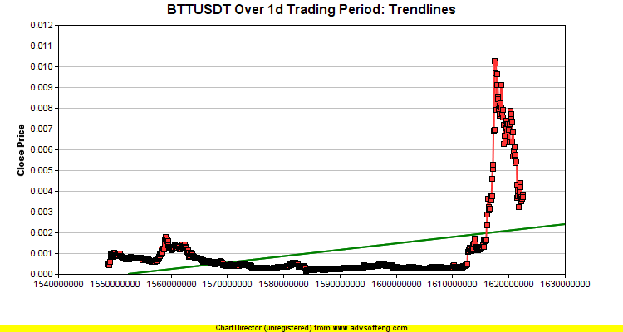
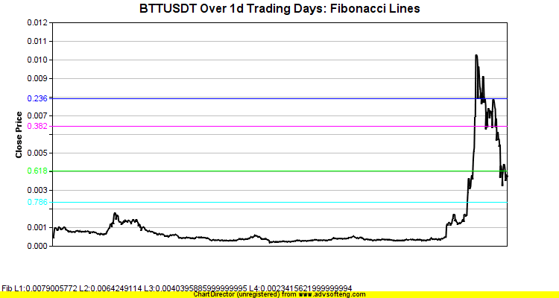
Detected Harmonic Pattern BullishCrabbinance-BTTUSDT-1d.png
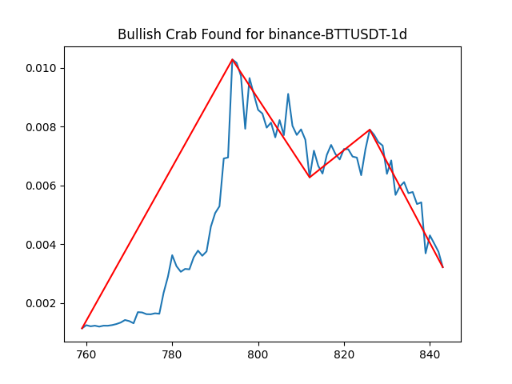
Head and Shoulder BTTUSDT Lookback=1000(uses hourly data)
CANDLE PATTERN DETECTED for BTTUSDT CDL3OUTSIDE with BULLISH signal at date time: 2021-05-24 20:00:00
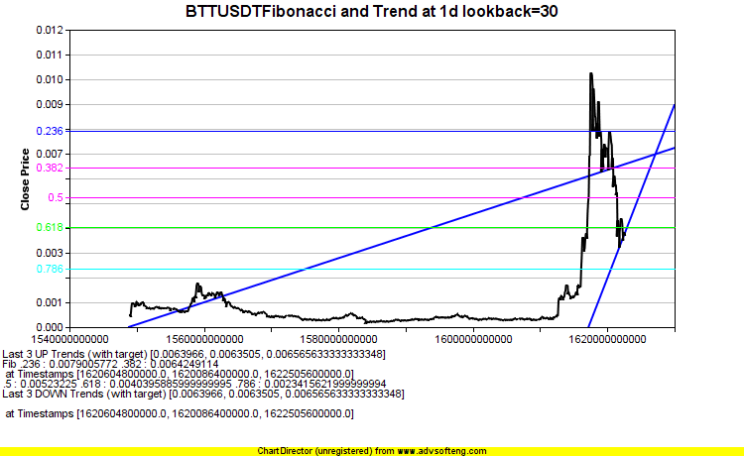
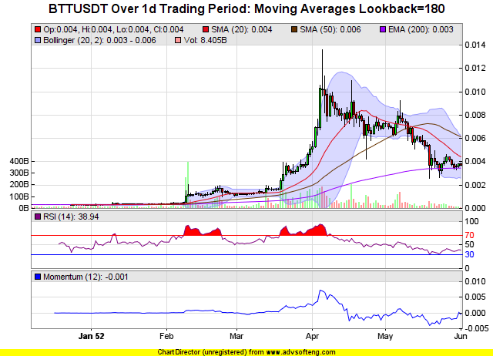
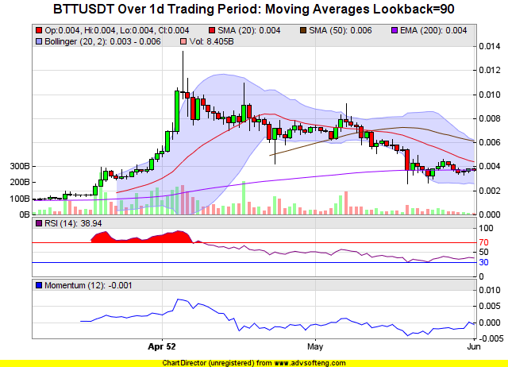
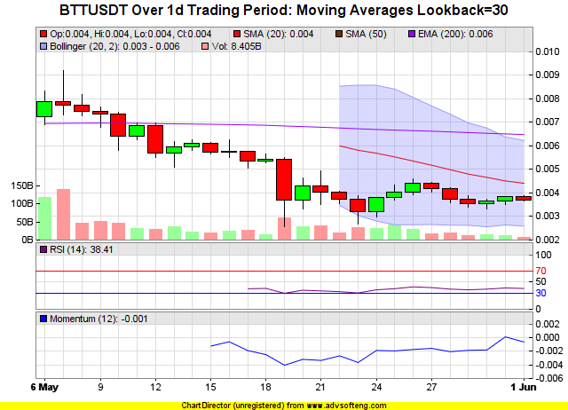

SHIBUSDT
Standard Deviation 0.22769852390117018
Volume 19,204,666,101,656.0
Fibonacci (Price <= Golden Range) True
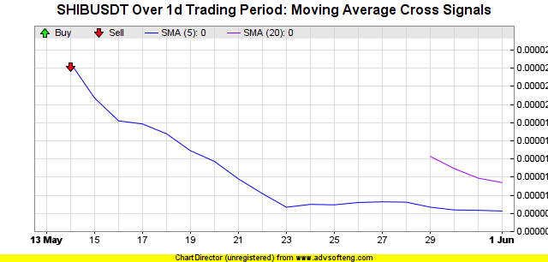
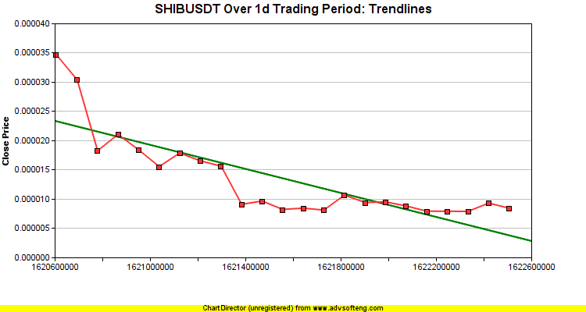
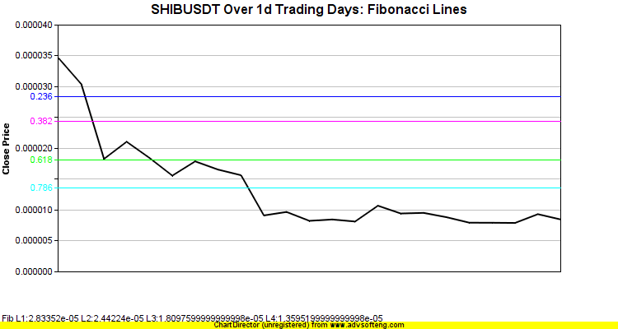
Head and Shoulder SHIBUSDT Lookback=1000(uses hourly data)
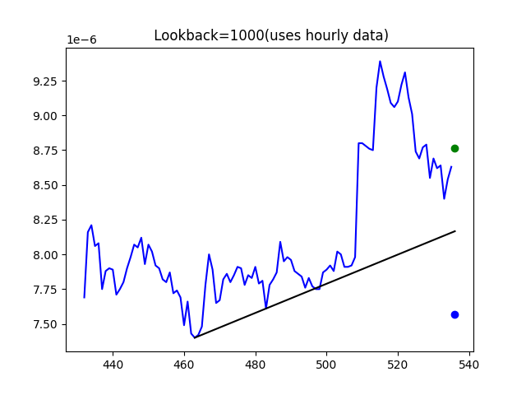
CANDLE PATTERN DETECTED for SHIBUSDT CDLMARUBOZU with BEARISH signal at date time: 2021-05-31 20:00:00
CANDLE PATTERN DETECTED for SHIBUSDT CDLMATCHINGLOW with BULLISH signal at date time: 2021-05-28 20:00:00
CANDLE PATTERN DETECTED for SHIBUSDT CDLMATCHINGLOW with BULLISH signal at date time: 2021-05-29 20:00:00
CANDLE PATTERN DETECTED for SHIBUSDT CDL3STARSINSOUTH with BULLISH signal at date time: 2021-05-28 20:00:00
CANDLE PATTERN DETECTED for SHIBUSDT CDL3STARSINSOUTH with BULLISH signal at date time: 2021-05-29 20:00:00
CANDLE PATTERN DETECTED for SHIBUSDT CDLSEPARATINGLINES with BULLISH signal at date time: 2021-05-30 20:00:00
